UDP Socket Programming Lab Manual

Lab Objective:
This lab is designed to introduce UDP socket programming and its use for building client-server applications. You will develop two programs:
- UDP Daytime Client – A client that sends a request to the UDP Echo Server and receives the current date and time.
- UDP Echo Server – A server that listens for incoming messages from the client and sends the same message back (echoes it).
Additionally, you will implement a UDP Ping Application to calculate the Round-Trip Time (RTT) between a client and server.

Theory Overview:
UDP (User Datagram Protocol) is a connectionless protocol that allows applications to send data packets to another device without the overhead of establishing and maintaining a connection. Unlike TCP, UDP does not guarantee delivery or order of packets. This makes UDP faster but less reliable, which is ideal for applications that require speed over reliability (e.g., live streaming, online gaming).
Some Real-life Examples:
- Online gaming (like PUBG, Fortnite, or Counter-Strike)

- Voice-over-IP (VoIP) applications (like WhatsApp calls or Skype)

- DNS lookups for fast domain name resolution

- Live sensor data transmission in IoT systems
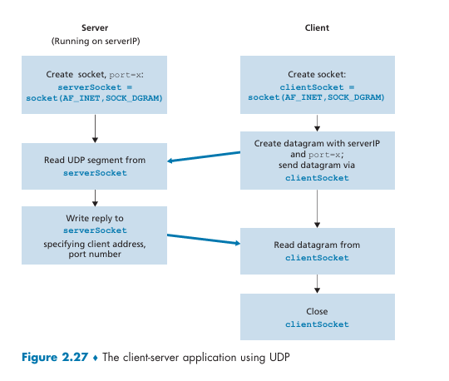

Socket Types:
- UDP Socket (Datagram Socket): Uses SOCK_DGRAM and is ideal for connectionless communication.
- TCP Socket (Stream Socket): Uses SOCK_STREAM for connection-oriented communication.
Round-Trip Time (RTT) in a UDP echo socket measures the time taken for a message to travel from the client to the server and back.
It helps you understand the network delay between the two devices.
RTT is calculated by recording the time just before sending the message and right after receiving the reply, then finding the difference.
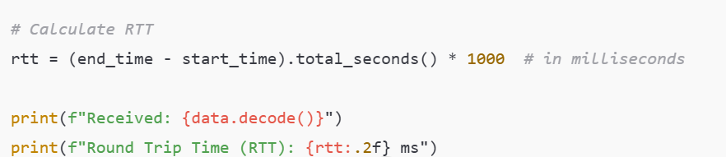
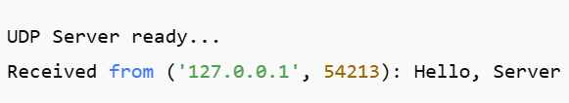
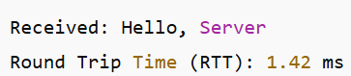

Lab Tasks and Procedure:

Task 1: UDP Daytime

Steps:
- Create a UDP socket for the client using Python's socket module.
- Define the server's IP address and port (localhost, port 12345).
- Send a request to the server for the current date and time.
- Receive the current date and time from the server.
- Display the received message (current date and time) on the client's console.
- Close the socket after receiving the response.

Code for UDP Daytime Server:

Library for socket
Library for Datetime
# 1. Create UDP socket
server_socket = socket.socket(socket.AF_INET, socket.SOCK_DGRAM)

# 2. Bind server to localhost and port 12345

print("UDP Server is running and waiting for client request...")

# 3. Receive message from client
print("Received message from client:", data.decode())

# 4. Get current date and time

# 5. Send date and time back to client

Code for UDP Daytime Client:
import socket

# 1. Create UDP socket

# 2. Server address and port

# 3. Send request for datetime

# 4. Receive the datetime from the server
print("Current Date and Time from Server:", data.decode())

# 5. Close socket

Expected Output on Client Side:
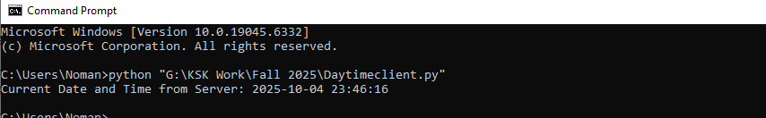
Task 2:
To develop a UDP-based client-server application that exchanges messages using socket programming in Python. The server should listen for messages sent by the client, display the received message along with the client’s address, and then send back the same message with the current date and time appended to it. The client should allow the user to enter a message, send it to the server, and display the echoed response containing the message and timestamp received from the server. The client also calculates the Round-Trip Time (RTT), which is the time taken from sending the ping to receiving the pong, and displays the RTT in milliseconds. The communication continues until the client sends the message "exit," which causes both the client and the server to terminate gracefully. This program demonstrates real-time message exchange, date-time integration, and RTT measurement using UDP sockets.

Conclusion:
In this lab, you have learned how to implement UDP-based client-server applications. You explored UDP socket programming, understood how connectionless communication works, and observed how to calculate Round-Trip Time (RTT) in a UDP-based ping application.
Home Task: UDP File Transfer
You are required to implement a UDP-based file transfer application that includes a ping-pong mechanism and Round Trip Time (RTT) calculation. The client will first send a “ping” message to the server to check the connection status. The server will reply with a “pong” message, confirming readiness to receive data. The client will then calculate the RTT based on the time taken between sending “ping” and receiving “pong.” After confirming connectivity, the client will start sending the file to the server in UDP packets. The server will receive the file, store it locally, and send a confirmation message back to the client upon successful transfer. Both the client and server will include basic error handling to detect and handle lost packets or transmission errors, ensuring reliable file transfer even though UDP is a connectionless protocol

